**QUESTION NO :41**

Design and implement a console-based News Aggregator to manage sources, fetch articles

(simulated), categorize, and deliver user digests using OOP in Java.

**Requirements:**

**1. Create at least 4 classes**:

* Subscriber – id, name, email, preferences, plan. o Source – sourceId, name, category (Tech/Sports), trustScore. o Article – articleId, title, category, publisher, publishTime. o NewsService – manage sources, fetch/filter articles, build digests.

**2.Each class must include**:

* ≥4 instance/static variables. o A constructor to initialize values.
* ≥5 methods (getters/setters, addSource(), fetch(), filter(), buildDigest()).

**3. Demonstrate OOPS Concepts:**  o Inheritance → PaidSubscriber/FreeSubscriber extends Subscriber with limits. o Method Overloading → filter() by category, time window, or keyword. o Method Overriding → digest length/rules differ for Paid vs Free.

* Polymorphism → maintain List<Subscriber> and generate digests dynamically. o Encapsulation → guard subscription plan and delivery lists.

**4.Write a main class(NewsAppMain) to test:**

* Add source/subscribers, simulate fetch, filter, and build digests. o Print per-user digests and source trust reports.

**CODE:**

package program; import java.util.*; import java.time.*; **// ---------- Article ----------** class Article { private int articleId; private String title; private String category; private String publisher; private LocalDateTime public Article(int articleId, String title, String category**,** String publisher, LocalDateTime publishTime) { publishTime; this.articleId = articleId**;**  this.title = title;

this.category = category; this.publisher = publisher; this.publishTime = publishTime;

}

public int getArticleId() { return articleId; } public String getTitle() { return title; } public String getCategory() { return category; } public String getPublisher() { return publisher; } public LocalDateTime getPublishTime() { return publishTime; }

@Override public String toString() { return "[" + category + "] " + title + " - " + publisher + " (" + publishTime.toLocalTime() +

")";

}

}

**// ---------- Source ----------** class Source {

private int sourceId; private String name; private String category; private double trustScore; name, String category, double trustScore) { this.sourceId=sourceId; public Source(int sourceId,string,name,string category,double trustscore);

}

this.name = name; this.category = category; public int getSourceId() { return sourceId; } public String getName() { return name; } public String getCategory() { return category; } public double getTrustScore() { return trustScore; } public void setTrustScore(double trustScore) { this.trustScore = trustScore; }

@Override

public String toString() { return "Source: " + name + " (" + category + ") TrustScore=" + trustScore;

}

}

**// ---------- Subscriber (Base Class) ----------** abstract class Subscriber { private int id; private String name; private String email; private List<String> preferences;

private String plan; public Subscriber(int id, String name, String email, List<String> preferences, String plan) { this.id = id;

this.name = name; this.email = email; this.preferences = preferences; this.plan = plan;

}

public int getId() { return id; } public String getName() { return name; } public String getEmail() { return email; } public List<String> getPreferences() { return preferences; } public String getPlan() { return plan; } public abstract List<Article> buildDigest(List<Article> fetchedArticles);

}

**// ---------- FreeSubscriber ----------** class FreeSubscriber extends Subscriber { public FreeSubscriber(int id, String name, String email, List<String> preferences) { super(id, name, email, preferences, "FREE");

}

@Override public List<Article> buildDigest(List<Article> fetchedArticles) {

// Free plan: max 3 articles

List<Article> digest = new ArrayList<>(); for (Article a : fetchedArticles) { if (getPreferences().contains(a.getCategory())) { digest.add(a); } if (digest.size() == 3) break;

}

return digest;

}

}

**// ---------- PaidSubscriber ----------** class PaidSubscriber extends Subscriber { public PaidSubscriber(int id, String name, String email, List<String> preferences) { super(id, name, email, preferences, "PAID");

}

@Override

public List<Article> buildDdArticles) {

// Paid plan: unlimited but filter by preferenceigest(List<Article> fetche

List<Article> digest = new ArrayList<>(); for (Article a : fetchedArticles) { if (getPreferences().contains(a.getCategory())) digest.add(a);

} }

return digest;

}

}

**// ---------- NewsService ----------** class NewsService { private List<Source> sources = new ArrayList<>(); private List<Article> articles = new ArrayList<>(); private List<Subscriber> subscribers = new ArrayList<>(); public void addSource(Source s) { sources.add(s); } public void addSubscriber(Subscriber s) { subscribers.add(s); }

**// Simulated fetch**

public void fetchArticles() { articles.clear(); int id = 1;

**s**.getName(),for (Source s : sources) **{** articles.add(new Article(id++, "Latest from "

s.getCategory(), s.getName(), LocalDateTime.now().minusMinutes(new Random().nextInt(60))));

}

}

**// Overloaded filters**

public List<Article> filter(String category) { List<Article> res = new ArrayList<>(); for (Article a : articles) { if (a.getCategory().equalsIgnoreCase(category)) res.add(a);

}

return res;

}

public List<Article> filter(LocalDateTime since) { List<Article> res = new ArrayList<>(); for (Article a : articles) { if (a.getPublishTime().isAfter(since)) res.add(a); return res;

}

public List<Article> filterByKeyword(String keyword) { List<Article> res = new ArrayList<>(); for (Article a : articles) { if (a.getTitle().toLowerCase().contains(keyword.toLowerCase())) res.add(a);

}

return res;

}

public void deliverDigests() { for (Subscriber s : subscribers) {

List<Article> digest = s.buildDigest(articles);

System.out.println("\n--- Digest for " + s.getName() + " (" + s.getPlan() + ") ---"); if (digest.isEmpty()) {

System.out.println("No articles found for preferences.");

} else {

for (Article a : digest) {

System.out.println(a);

}

}

}

}

public void trustReport() {

System.out.println("\n--- Source Trust Report ---"); for (Source s : sources) {

System.out.println(s);

}

}

}

**// ---------- Main Class --------** public class main {

**// TODO Auto-generated method stub**

public static void main(String[] args) {

NewsService service = new NewsService();

**// Add sources**

service.addSource(new Source(1, "TechCrunch", "Tech", 8.5)); service.addSource(new Source(2, "ESPN", "Sports", 9.0)); service.addSource(new Source(3, "Wired", "Tech", 8.0)); service.addSource(new Source(4, "SkySports", "Sports", 7.5));

**// Add subscribers**

service.addSubscriber(new FreeSubscriber(1, "Alice", "alice@mail.com", Arrays.asList("Tech")));

service.addSubscriber(new PaidSubscriber(2, "Bob", "bob@mail.com", Arrays.asList("Tech", "Sports")));

**// Simulate fetch**

service.fetchArticles();

**// Deliver Digests**

service.deliverDigests();

**// Trust Report**

service.trustReport();

**// Example filtering**

System.out.println("\n--- Filtered by Category 'Tech' ---");

for (Article a : service.filter("Tech")) {

System.out.println(a);

}

}

**OUTPUT:**

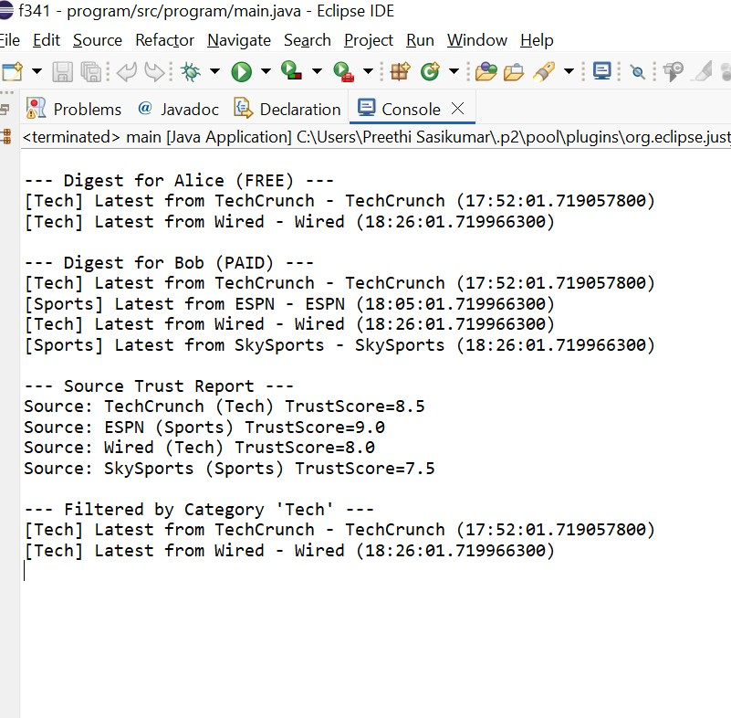

**GITHUB LINK : https://github.com/rakexh2007/717824F141**